


Allen + Clarke Summary of the Key Takeaways
2 December 2025
Beehive to Business with the Honourable Todd McClay
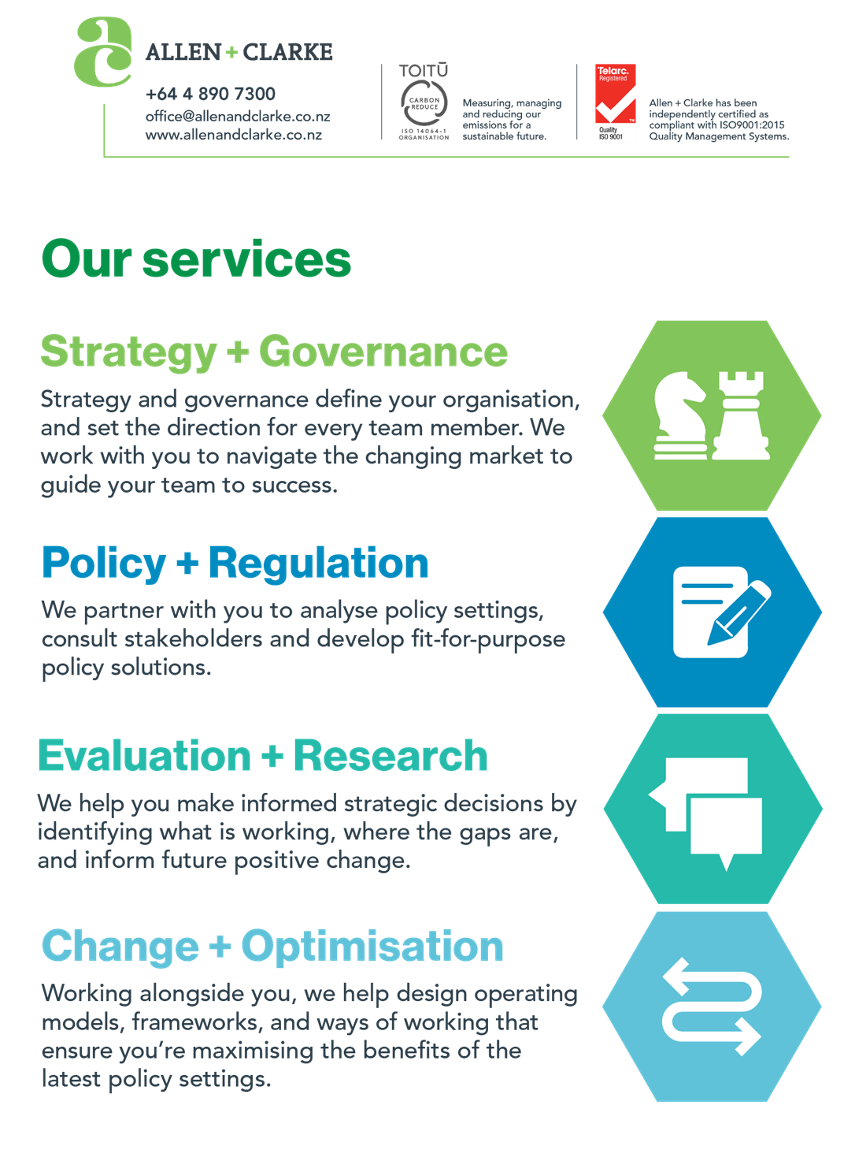
Table of contents
Trade policy and export growth strategy 3
Free trade agreements and market access 4
United States tariff challenges and responses 5
India trade deal negotiations 7
Resource management reform and productivity 8

Please note: This is Allen + Clarke’s interpretation of the key messages from the session. Whilst we aim to reflect the discussion as accurately as possible, some parts may have been interpreted differently to other attendees and the intended messages of the speaker.
This summary was created by Anton Davis (Director Consulting NZ) and Ashley Yee (Marketing Manager) with the assistance of AI for transcription and drafting.

Foreword
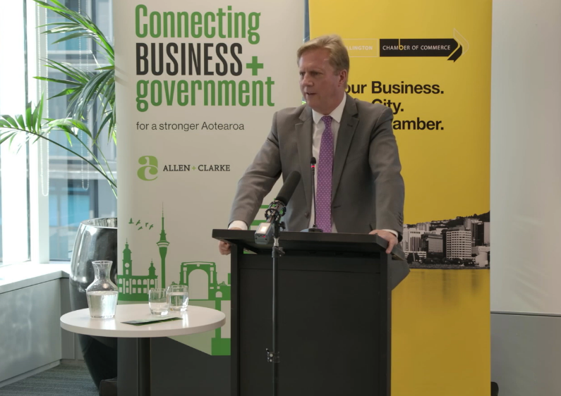
In the recent Wellington Chamber of Commerce Beehive to Business breakfast, the Honourable Todd McClay outlined New Zealand's ambitious trade agenda and the strategic opportunities emerging across global markets. His comments signal significant momentum in trade negotiations and highlight immediate opportunities for businesses to capitalise on new market access while navigating global uncertainty.
Minister McClay holds the Agriculture, Forestry and Trade and Investment portfolios, positioning him uniquely to champion New Zealand's export economy. He described his role as Minister of Agriculture as "the easiest job in the world" due to the quality and innovation of New Zealand farmers, whilst acknowledging trade negotiations remain difficult because food remains one of the least traded yet most heavily protected commodities globally.
The Minister's overarching message centred on creating certainty for exporters through ambitious trade agreements and removing policy volatility. With New Zealand achieving over $100 billion in exports and the primary sector reaching $60 billion, his remarks emphasised that government's role is to level the playing field internationally while backing businesses to make their own strategic decisions about markets and risk.

Trade policy and export growth strategy
Key points
- New Zealand has set an ambitious target to double the value of exports over ten years, moving beyond volume to value growth.
- Total exports have reached $108 billion for the first time, with the primary sector achieving $60 billion.
- Government has conducted 17 high-quality trade missions since election, with approximately $2 billion worth of deals signed during these missions.
- 80% of goods exports come from the primary sector, though the strategy emphasises diversification across services, innovation, high tech, science and tourism.
- Trade policy focuses on creating certainty and levelling the playing field rather than government directing where businesses should invest.

Summary of the discussion
Minister McClay positioned the export doubling target as deliberately provocative, noting he received criticism for being "ambitious for New Zealand" but that this ambition has rallied both civil service and business around a common goal. He emphasised that success will be measured "as much on how much extra we export as the number of deals that we do." The Minister drew a clear distinction between government's role in creating conditions for success versus picking winners, stating: "It is not for us to tell you what you should do. It is to level the playing field, to try and give you certainty, set up rights and obligations within trade agreements, and then work with you to work out where you should put your effort."
The horticulture sector has set ambitious targets aligned with the government's vision. RMA changes could enable environmental improvements whilst freeing innovation and expansion. The Minister credited the business community for stepping up in uncertain times to drive sustainable long-term growth.
 The only real restriction is the one we place upon ourselves.

Potential actions for organisations in export and primary sectors
- Engage with upcoming trade missions to priority markets, as ministerial presence accelerates contract signings and brings decision-making forward.
- Review your export strategy against the doubling target framework, identifying specific markets and value-add opportunities that align with new trade agreements.
- Connect with sector groups developing growth targets and RMA reform proposals, as government is actively seeking business-driven solutions to regulatory barriers.

Potential actions for organisations outside these sectors
- Examine how your products or services could support export-focused businesses, from logistics and packaging to technology and financial services.
- Consider export market diversification opportunities in your strategic planning, particularly in regions where government is securing improved access.
- Leverage New Zealand's improving trade reputation internationally by highlighting association with high-quality, safe, and innovative production systems.

Free trade agreements and market access

Key points
- EU New Zealand FTA has delivered exceptional results, with exports to the European Union increasing by $2 billion in its first year of operation.
- UAE trade deal was negotiated in just over three and a half months, entering into force with 98.7% of exports tariff-free.
- GCC trade deal with Saudi Arabia and partners took six months to complete, providing 80% tariff-free access on entry, rising to 99% over ten years.
- New Zealand has approximately 100 free trade, investment or double tax agreements covering most major economies.
- The government maintains an "and trade policy" – pursuing relationships with US, China, EU, India, Middle East and other markets simultaneously.

Summary of the discussion
The Minister highlighted the EU FTA's performance as validation of the government's trade strategy, particularly during a period when US tariffs were projected to cost New Zealand $900 million to $1.3 billion. The speed of the UAE and GCC negotiations represents a significant shift in New Zealand's approach, with the Minister emphasising that countries actively want to negotiate with New Zealand.
The Minister positioned these agreements as creating immediate opportunities that businesses must seize independently: "Go and jump on the plane, Emirates, direct to Dubai, talk to people. They want what we produce and they are willing to pay very, very well for it." Beyond consumption markets, the UAE represents a regional hub where New Zealand products can be value-added and exported throughout the broader region.

Potential Actions for organisations in food and beverage sectors
- Prioritise market development activities in the UAE and GCC countries, where tariff-free access and high-value consumers create immediate opportunities.
- Explore the European Union market systematically, as the $2 billion export growth demonstrates significant untapped demand for New Zealand products.
- Investigate regional distribution opportunities through Dubai and other GCC hubs that can serve as gateways to Middle Eastern and African markets.

Potential actions for organisations outside these sectors
- Review how your business could support companies entering UAE, GCC or EU markets through services, partnerships or supply chain integration.
- Consider the broader economic impacts of increased trade flows to these regions on freight, logistics and professional services demand.

United States tariff challenges and responses

Key points
- United States imposed 10% tariffs on New Zealand as part of universal tariff policy, increased to 15% due to modest trade surplus.
- President Trump subsequently dropped tariff rates back to MFN or zero for approximately 30% of New Zealand exports, including key products like beef, turkey and pork.
- New Zealand's beef trade has been resilient, with tariffs largely passed through to consumers.
- The primary concern is uncertainty and volatility rather than tariff rates themselves, with rates changing multiple times during single shipments.
- Despite initial projections of $900 million to $1.3 billion losses from tariffs, actual impact has been significantly less due to market adjustments.

Summary of the discussion
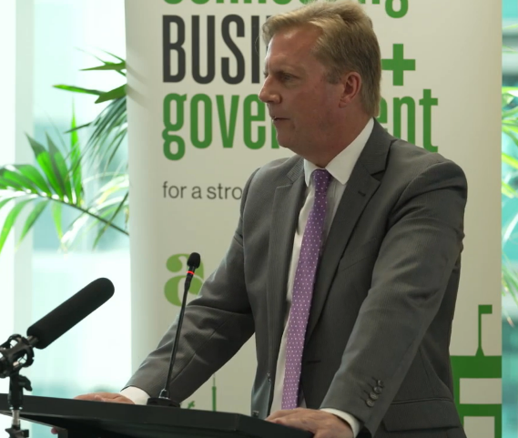
Minister McClay acknowledged the US tariff situation with directness, noting "there's no magic solution" but emphasising New Zealand has been treated consistently with other nations facing similar circumstances. He described meeting with US Trade Representative Jameson Greer, who explained that having even "$1 more" in imports than exports to the US would have kept New Zealand at 10% rather than 15%. The Minister noted that Switzerland received 39% tariffs, providing context for New Zealand's treatment.
The Minister emphasised that predictability matters more than specific tariff levels for exporters making commercial decisions. He referenced the example of a ship from the EU where tariff rates changed four to five times between departure and arrival, making it impossible to plan pricing or profitability. New Zealand's approach has been to "create certainty everywhere else in the world" whilst continuing to advocate for predictable US treatment. The Minister cautiously welcomed the MFN reset for key products but stressed that "what is taken away with the swipe of a pen can be put back again."

Potential actions for organisations exporting to the United States
- Develop pricing flexibility and hedging strategies to manage tariff volatility, rather than assuming stable rates for the foreseeable future.
- Explore whether your products qualify for the MFN or zero tariff categories, as approximately 30% of New Zealand exports now benefit from reduced rates.
- Maintain US market presence and relationships despite uncertainty, as Minister McClay confirmed government will continue advocating for improved predictability.

Potential actions for organisations outside these sectors
- Factor US tariff uncertainty into supply chain and business planning, particularly for inputs or customers dependent on US export markets.
- Consider market diversification strategies that reduce concentration risk in the US market, leveraging new opportunities in EU, Middle East and India.
- Monitor how US tariff patterns affect your competitive position relative to businesses in other jurisdictions facing similar or different treatment.

India trade deal negotiations

Key points
- Prime Minister set target to complete India trade deal within first three years of government, with negotiations launched 21 March 2024.
- Minister McClay has visited India seven times since election, with New Zealand negotiators conducting approximately 20 visits.
- Cabinet decision-making process established where Minister McClay and Indian counterpart Minister Piyush Goyal intervene directly when negotiators encounter roadblocks.
- Negotiators now talk daily with both ministers checking in on progress to maintain momentum and make quick decisions.
- Prime Minister Modi specifically named New Zealand alongside EU and Norway when announcing accelerated trade negotiations following US tariff announcements.

Summary of the discussion
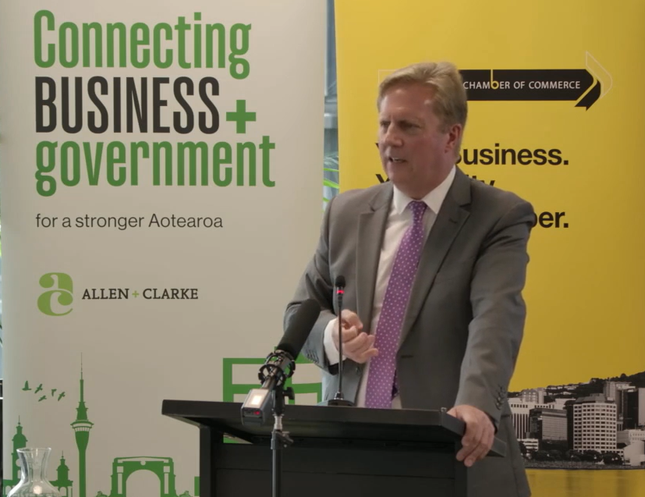
Minister McClay positioned the India negotiations as transformative, describing the opportunity as "a little country of 5 million people compared to 1.4 billion people with a growing middle class who have the ability to buy everything we produce 10 times over." He characterised the approach as fundamentally different from traditional trade negotiations, treating it like a business relationship rather than adversarial negotiation.
The Minister explained that he and Minister Goyal agreed early to "only launch the agreement if we are committed to doing it in a reasonable timeframe," with both ministers directly resolving roadblocks to keep negotiators moving. This approach has incentivised officials to make decisions themselves rather than constantly escalating. The Minister expressed confidence that completing the deal during this parliamentary term would be "as significant in time as our trade agreement with China and our trade agreement with the European Union."

Potential actions for organisations in export sectors
- Begin market research and relationship building in India now, particularly in major urban centres and growing middle-class consumption areas.
- Prepare capability statements and market entry strategies for rapid deployment once the trade agreement enters into force.
- Connect with MFAT trade officials or New Zealand Trade and Enterprise to understand specific opportunities in your sector under the developing agreement.

Potential actions for organisations outside these sectors
- Consider how your products or services could support businesses entering the Indian market, from market intelligence to logistics and compliance services.
- Evaluate partnership opportunities with Indian businesses that could benefit from New Zealand expertise, technology or quality positioning.
- Factor the India opportunity into long-term strategic planning, recognising this represents one of the largest market access gains in New Zealand's trade history.

Resource management reform and productivity

Key points
- RMA reform described as "replacement" not reform, representing fundamental transformation of resource management system.
- Current system satisfies nobody, with even environmentalists dissatisfied with outcomes.
- Changes designed to reduce costs for farmers and businesses by simplifying rules whilst maintaining environmental obligations.
- Reform considered essential to enabling New Zealand's productivity growth and housing affordability over time.

Summary of the discussion
Minister McClay acknowledged that the RMA reform has the potential to "transform the economy over time, make it easier for New Zealanders to do what they want." He positioned the reform as critical to reducing costs across the primary sector, noting that government can't control world market prices but has "an absolute obligation to simplify rules, to make it easier for farmers to meet their obligations, and to get costs down."
The Minister argued that current Wellington-based policymaking without farm visits creates costs and red tape that undermine productivity. He connected this to climate commitments, emphasising New Zealand remains committed to Paris Agreement targets and net zero by 2050, but "the debate is how we achieve that without putting costs upon you and putting people out of business."
The Minister linked RMA reform to housing affordability, explaining that expensive Tauranga land compared to Rotorua stems from insufficient building and restrictive rules. Combined with falling interest rates from fiscal discipline, RMA reform will provide "the ability to do more of what you want yourself without government interference, more of your own money to spend, and actually a growing economy."
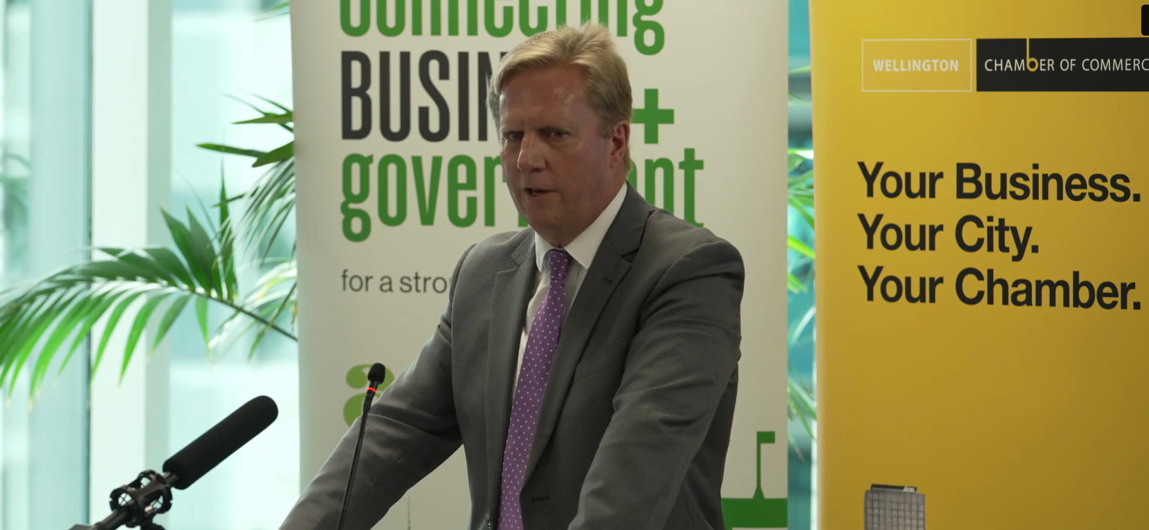

Potential actions for organisations in primary sector and construction
- Engage with RMA replacement consultation processes to ensure sector-specific concerns and opportunities are reflected in new legislation.
- Begin planning for how streamlined consenting could accelerate expansion, development or operational efficiency projects currently stalled by existing processes.
- Document specific examples of how current RMA requirements add cost without environmental benefit to inform policy development.

Potential actions for organisations outside these sectors
- Review how RMA reform could affect your supply chains, particularly for inputs from primary sector or construction-dependent services.
- Consider location and expansion decisions in light of potential for significantly faster consenting and reduced compliance costs post-reform.
- Identify opportunities where your business could benefit from or support increased economic activity enabled by more permissive resource management settings.



+64 4 890 7300
office@allenandclarke.co.nz
www.allenandclarke.com

